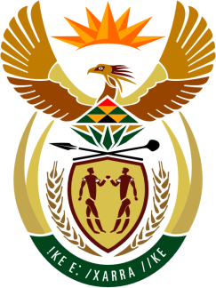

SOUTH AFRICAN PERMANENT MISSION TO THE UNITED NATIONS AND
OTHER INTERNATIONAL ORGANISATIONS

26th SESSION OF THE WORKING GROUP ON THE UNIVERSAL PERIODIC REVIEW

REVIEw of UGANDA

3 NOVEMBER 2016

PALAIS DES NATIONS

Check against delivery

Mr President,

South Africa welcomes the distinguished delegation of Uganda to this UPR Session and thanks the delegation for the presentation of its national report.

South Africa welcomes the commitment of Uganda to the promotion and protection of human rights, including the country’s efforts to improve access to legal aid services, including newly-established justice centres and legal aid clinics; the sizeable reduction in the mortality rate among prisoners arising from improved health care services in prisons; and the declines in infant mortality, neo-natal mortality, under-5 mortality and maternal mortality since the 2011 UPR.

We are encouraged by the introduction of human rights and civic education in schools and tertiary institutions; by the provision of human rights training to security personnel; by the establishment of shelters for victims of gender-based violence; and by the setting up of a national data base to monitor issues related to gender-based violence.

We recommend that Uganda:

- Capacitate and resource the Uganda Human Rights Commission in a sustainable manner;
- Strengthen implementation of the National Agricultural Policy to ensure access to food and address malnutrition;
- Enhance efforts to implement the National Action Plan on Women, in particular their participation and integration in the economy;
- Prioritise implementation of the Child Justice Strategy and of the National Diversion Guidelines for children in the criminal justice system.

We wish Uganda a very successful review during this Session.

I thank you.

